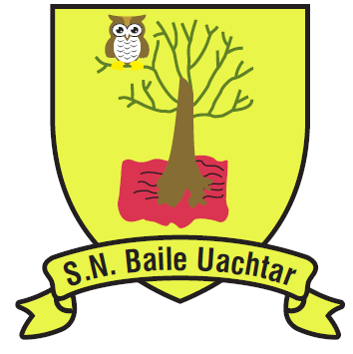
BALLYOUGHTER NATIONALSCHOOL
ANNUAL ADMISSION NOTICE
in respect of admissions to the 2021/2022 school year

Admission Policy and Application Form
A copy of the school’s Admission Policy and the Application Form for Admission for the 2021/2022 is available as follows: –
To download at: www.ballyoughterns.ie
On request: By emailing office@ballyoughterns.ie or writing to:
Ballyoughter NS, Ballyoughter, Gorey, Co. Wexford

PART 1 - Admissions to the 2012/2022 school year

Application and Decision Dates for admission to Ballyoughter NS
The following are the dates applicable for admission to Junior Infants

The school will commence accepting applications for admission on | 14/01/21
The school shall cease accepting applications for admission on | 04/02/21
The date by which applicants will be notified of the decision on their application is | 04/03/21
The period within which applicants must confirm acceptance of an offer of admission is | 31/03/21

Note: the school will consider and issue decisions on late applications in accordance with the school’s admission policy.

Number of places being made available in 2021/2022

The number of places being made available in junior infants is | 10

